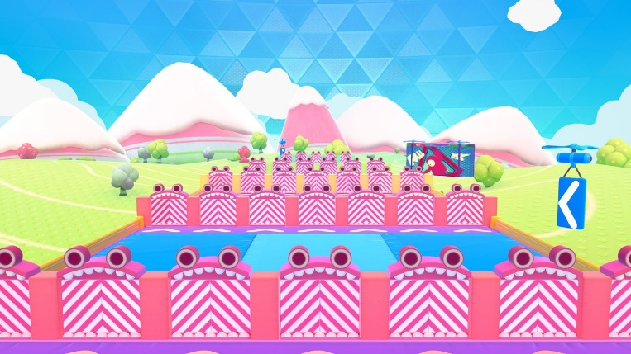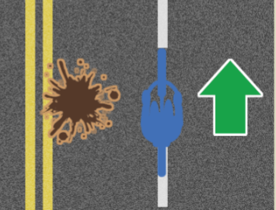

Hello Andrea!

today George completed another Roblox game using multiple concepts to make a super fun game teaching lots of stuff!  
  
Wall Runner is a game used in the popular Fall Guys set of games where a bunch of rows of doors are spawned in and then the game randomly selects doors to lock and doors to open! It's then up to the player to run through the walls and find out which ones are locked and which are unlocked. In fall guys it is a big race so you have to get lucky to find the correct doors or other players will overtake you as you struggle to locate the unlocked doors! In our game we will have a zombie chase the player as they run through to add some urgency to the game!  
  
George started today by creating the setting for the game and adding in all the different parts for our 'doors'. These doors where then placed in folders based on what row they are in. There are 5 doors on row 1, so we make sure to create a folder called 'Row 1' and add the 5 doors into it. Roblox folders are incredibly useful when coding as George can easily select all the parts in them. George once we have every folder for every row, we make a final folder and place all the other folders in that last one, folderception! Now onto the code!  
  
Firstly we need to select each row folder, so we run a for loop inside the main folder that contains them all. Then we need to select each part inside the folders, so we run another for loop! A for loop in a for loop is called a 'Nested' loop. Then we create a random number based on the size of the selected folder (how many doors are inside that row) and use this random number to select one of the doors at random, we then make this door unlocked! For more fun George also wanted to randomise every walls colour to make it look super cool! Finally, George added in a zombie and increased its speed to just below the players, so they can outrun it unless they hit too many locked doors!  
  
Great work today George you're doing great with all these games in Blue Belt!

~Sensei Lizzie